

|  |
| --- |
| [Version 1.1]  **Last saved by:** Ben McGregor  **Last saved on:** 31/03/2015 |

|  |
| --- |
| Iteration 5 Plan |
| 24/11/2014 |
| **Charlotte Hutchinson**  CO600: JustHealth Supervisor: Yang He |

Contents

1.0 Aims: 2

2.0 Requirements: 2

2.1 Functional requirements: 2

2.2 Non-functional requirements: 2

2.3 Domain Requirements: 3

3.0 Design 3

3.1 Android appointment design: 3

3.2 Web appointment design: 5

3.3 Android medication design 6

3.4 Web medication design 7

4.0 Use cases: 8

JustHealth Iteration 5 Plan

# Aims:

* To have a fully functioning way for carers to add medication details for patients.
* A secure and safe way to add medication details for patients to avoid human error
* For carers and patients to be able to add appointment details.
* The Android app to be integrated with the phones Google calendar.
* Reminder functionality for both android and web to remind patients to take medication and when appointments are.
* A notification system on both android and web so users are able to see requests or reminders.

# Requirements:

## 2.1 Functional requirements:

1. The ability for a carer to be able to enter in medication details for a patient- Web
2. The ability for a carer to be able to enter in medication details for a patient- Android
3. The ability for a patient or carer to enter appointment details- Web
4. The ability for a patient or carer to enter appointment details- Android
5. A reminder functionality to remind patients when to take medication- Web
6. A reminder functionality to remind patients when to take medication- Android
7. A reminder functionality to remind patients when appointments are- Web
8. A reminder functionality to remind patients when appointments are- android
9. Notification system- web
10. Notifications system- android
11. Linking with the android built in calendar

## 2.2 Non-functional requirements:

1. User Documentation
2. Security
   1. Ensuring only certain people can enter medication details
   2. A safe way for people to enter medication and unable to make human errors
   3. Secure ways of dealing with push notifications
   4. Safe connection with the android calendar
3. Robustness
   1. Error handling
   2. Security (as above)
4. Ease of Use
   1. Simple and intuitive design
   2. Clear colour scheme
   3. Clear and easy way for both patients and users to enter information

## 2.3 Domain Requirements:

1. Security (Android)
   1. Ensuring a user understands the connection with their phone calendar
   2. The app can only link with the google calendar rather then third party ones
2. Push notifications in Android linking with the google cloud
3. Legal
   1. Only correct medication can be entered, ensures validations on fields to prevent human error.
   2. Confirmation screen when medication has been entered

# Design

## 3.1 Android appointment design:

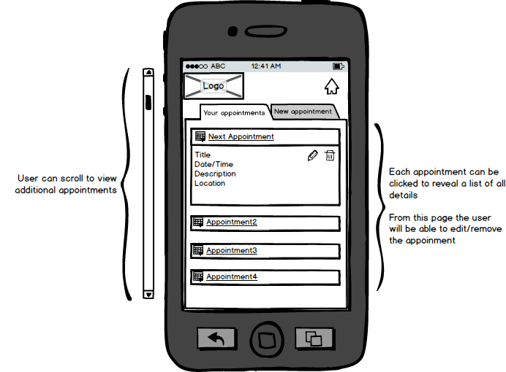

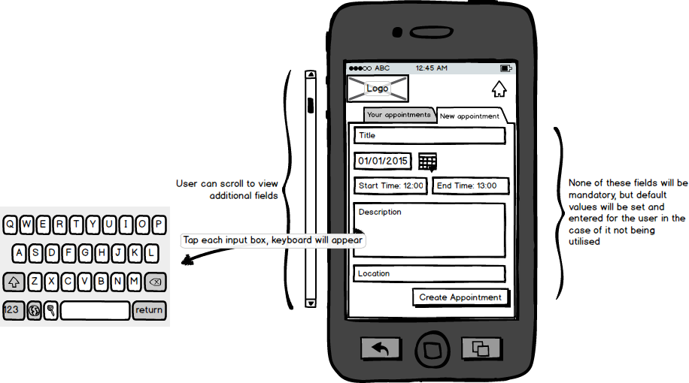

## 3.2 Web appointment design:

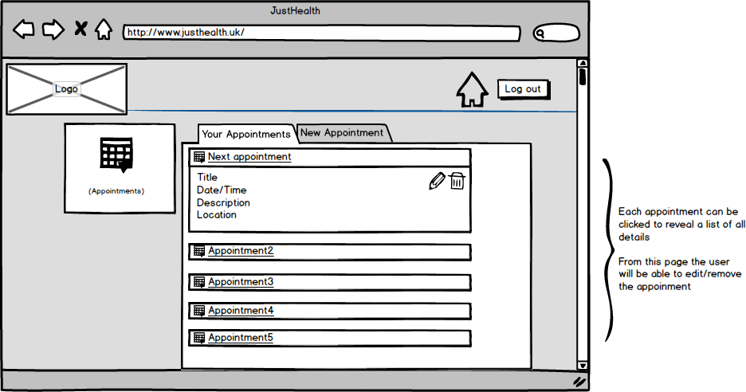  
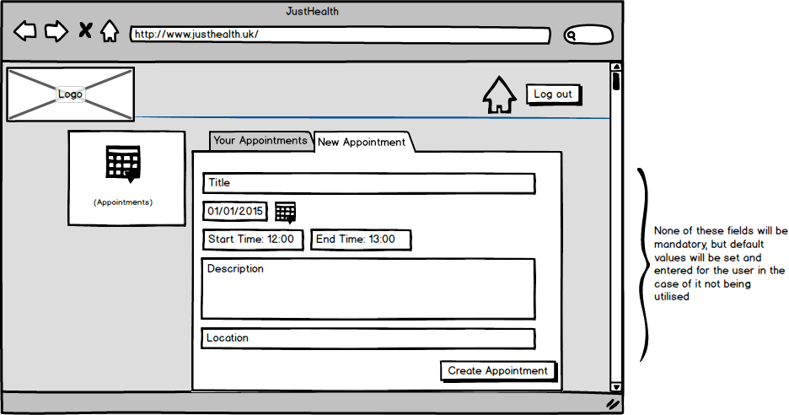

## 3.3 Android medication design

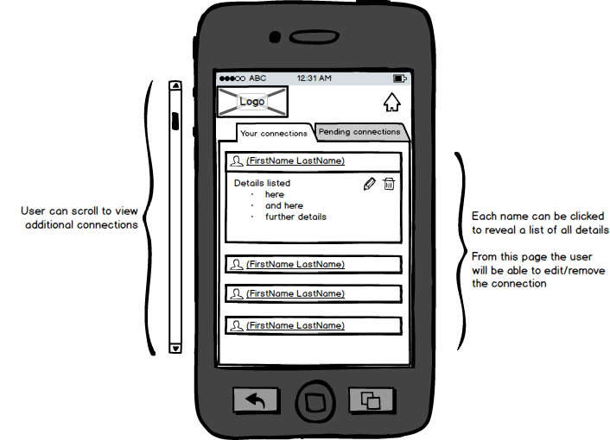

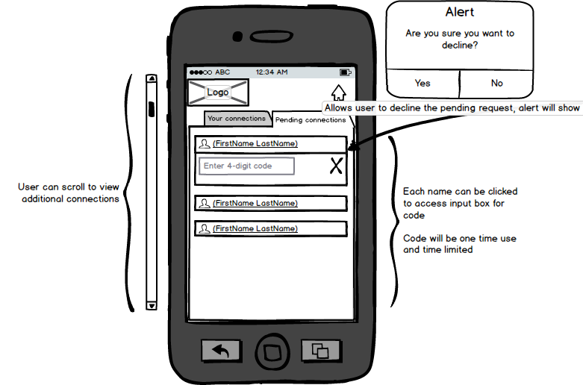

## 3.4 Web medication design

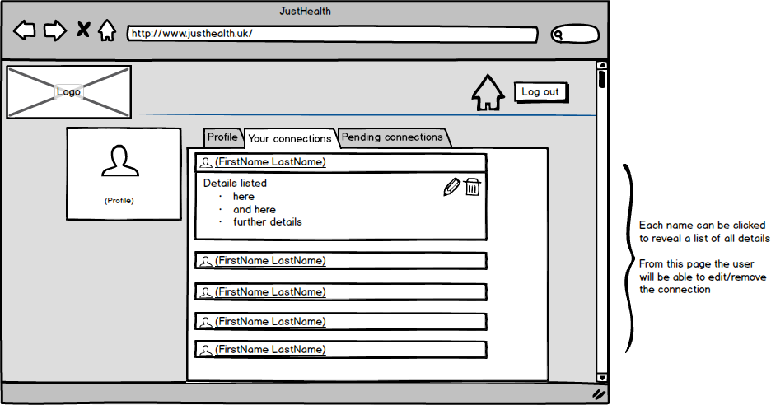

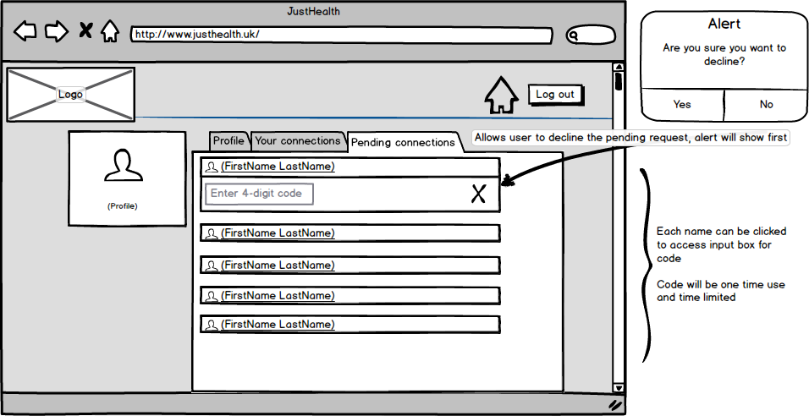

# 4.0 Use cases:

